Fully Automated Solar Grass Cutter

The fully automated solar grass cutter is a fully automated grass cutting robotic vehicle powered by solar energy that also avoids obstacles and is capable of fully automated grass cutting without the need of any human interaction. The system uses 6V batteries to power the vehicle movement motors as well as the grass cutter motor. We also use a solar panel to charge the battery so that there is no need of charging it externally. The grass cutter and vehicle motors are interfaced to an 8051 family microcontroller that controls the working of all the motors. It is also interfaced to an ultrasonic sensor for object detection. The microcontroller moves the vehicle motors in forward direction in case no obstacle is detected. On obstacle detection the ultrasonic sensor monitors it and the microcontroller thus stops the grass cuter motor to avoid any damage to the object/human/animal whatever it is. Microcontroller then turns the robotic as long as it gets clear of the object and then moves the grass cutter in forward direction again.

Block Diagram
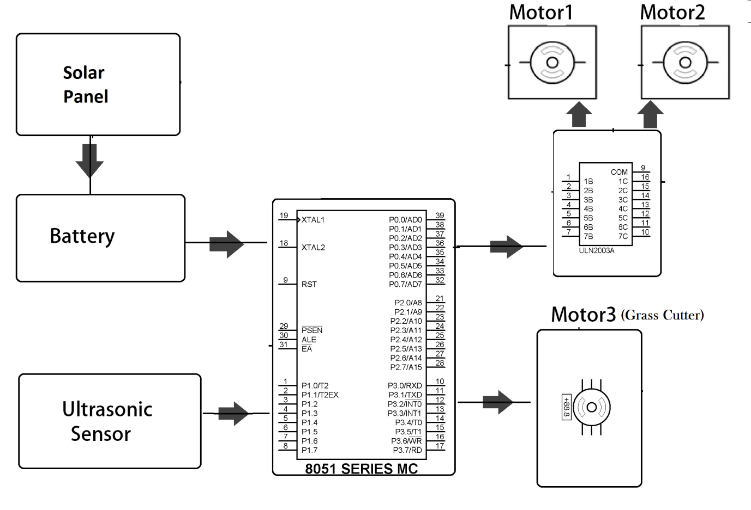

Hardware Specifications
  - 8051 Family Microcontroller
  - Solar Panel
  - Motor Driver IC
  - DC Motors
  - Ultrasonic Sensor
  - Batteries
  - Robotic Body

Software Specifications
- Keil µVision IDE
- MC Programming Language: Embedded C

ULTRASONIC SENSORS

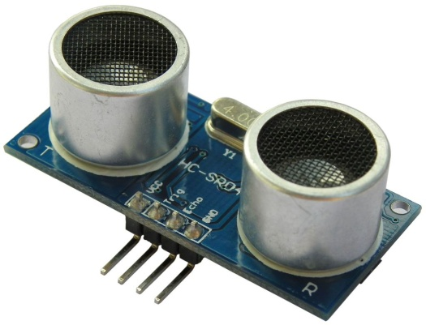
Ultrasonic sensors (also known as transceivers when they both send and receive) work on a principle similar to radar or sonar which evaluate attributes of a target by interpreting the echoes from radio or sound waves respectively. Ultrasonic sensors generate high frequency sound waves and evaluate the echo which is received back by the sensor. Sensors calculate the time interval between sending the signal and receiving the echo to determine the distance to an object.
This technology can be used for measuring: wind speed and direction (anemometer), fullness of a tank and speed through air or water. For measuring speed or direction a device uses multiple detectors and calculates the speed from the relative distances to particulates in the air or water. To measure the amount of liquid in a tank, the sensor measures the distance to the surface of the fluid. Further applications include: humidifiers, sonar, medical ultra sonography, burglar alarms and non-destructive testing.
Systems typically use a transducer which generates sound waves in the ultrasonic range, above 18,000 hertz, by turning electrical energy into sound, then upon receiving the echo turn the sound waves into electrical energy which can be measured and displayed.
The technology is limited by the shapes of surfaces and the density or consistency of the material. For example foam on the surface of a fluid in a tank could distort a reading.

